BADI Rule Context

Create Service

i) Open General settings 🡪 Process Modelling 🡪 workflow 🡪 Rule-Based Workflow 🡪 define service name for rule based workflow

ii) Click new entries and fill in the values eg: below

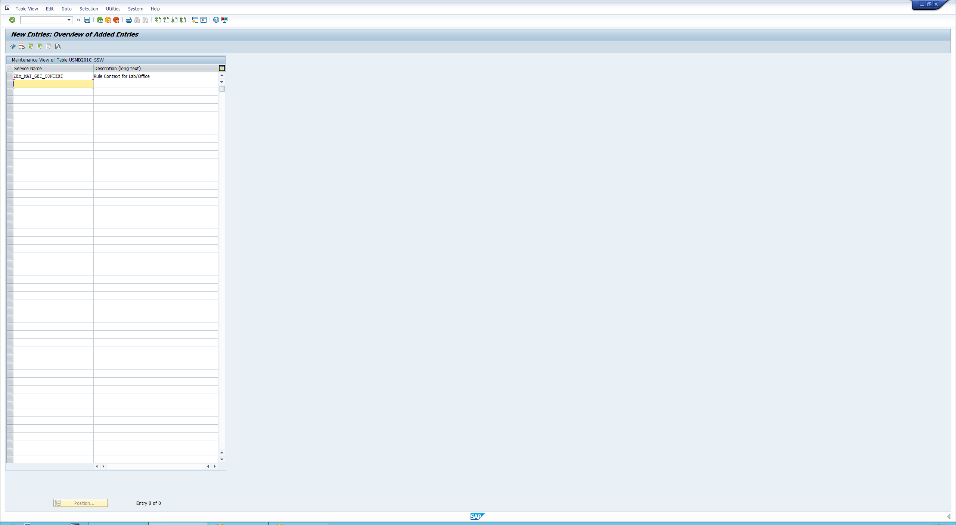

iii) Ensure to select your workflow transport when saving the new service.

Create Enhancement Implementation

i) Run transaction se18 to open enhancement spot

ii) When opened click enhancement spot and write USMD_SSW_SERVICE_PROCESSOR

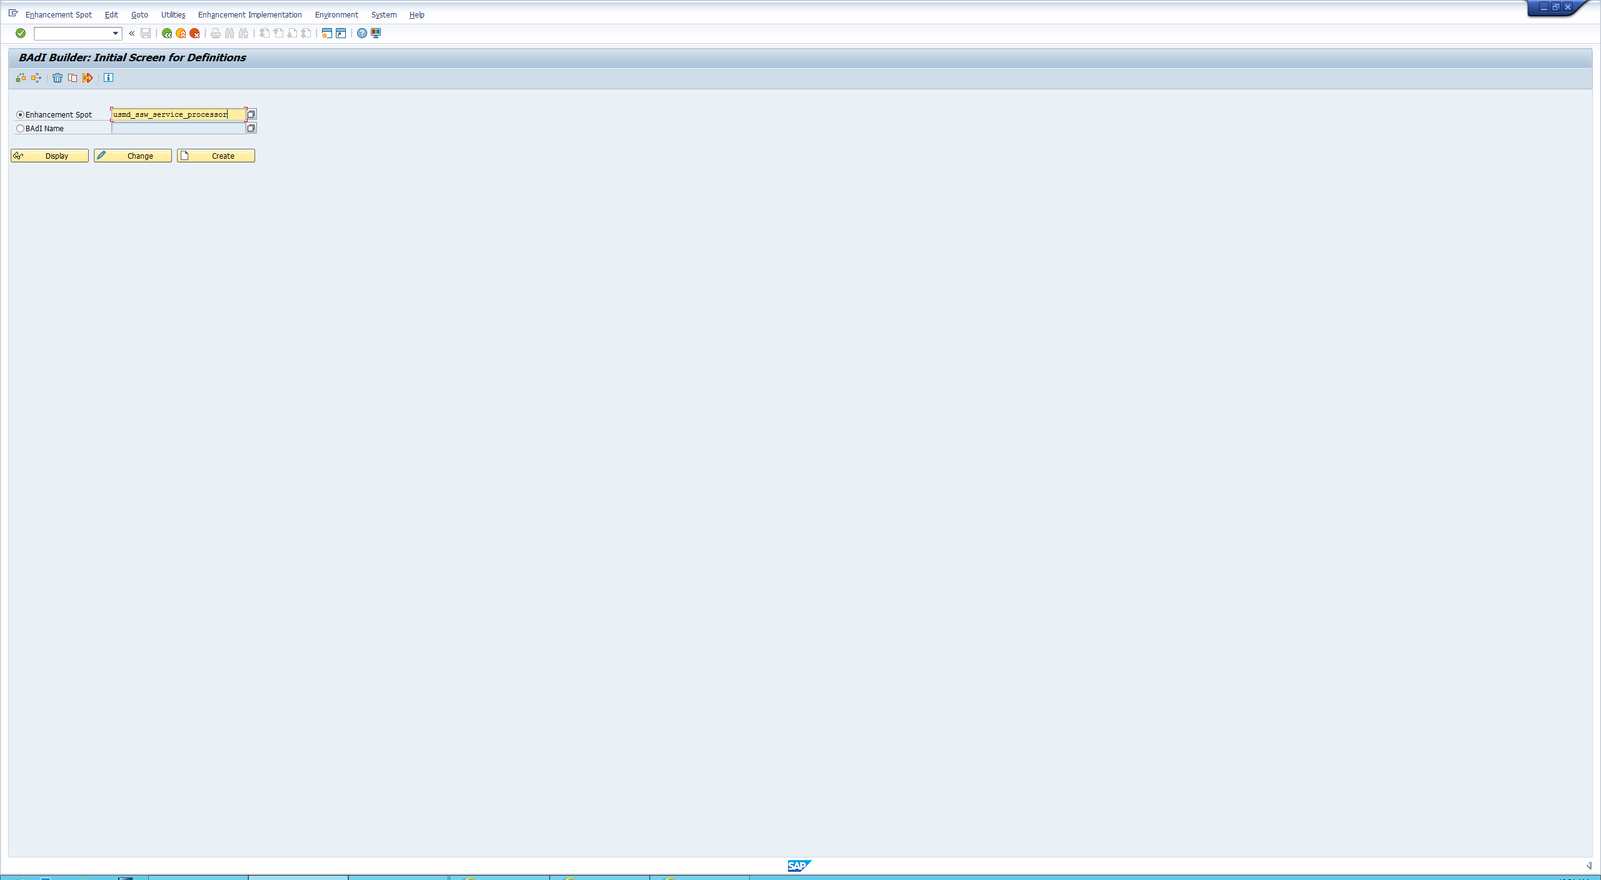

iii) dispay 🡪 Select USMD_SSW_RULE_CONTEXT_PREPARE

iv) IV) right click on implementations and click create BADI Implementation ensure you choose the Labor option

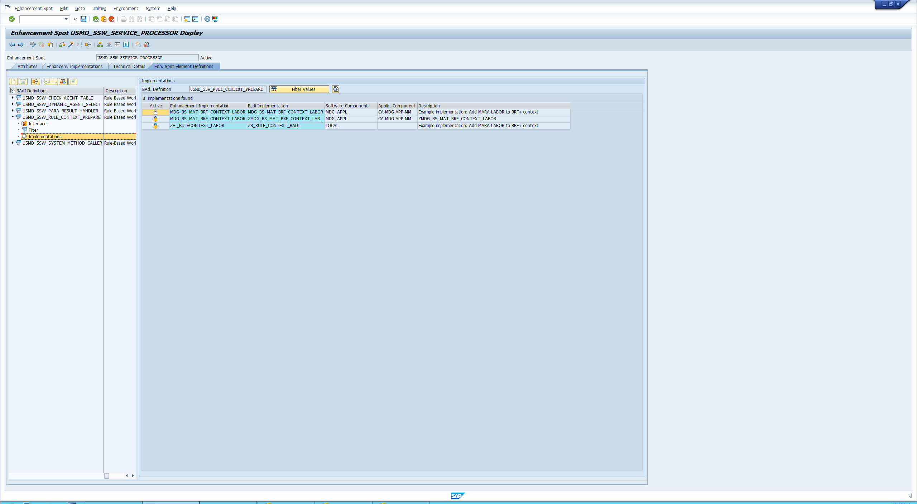

Create Badi Implementation

i) Fill in the values as shown below

BADI Implementation: ZMDG_BS_MAT_BRF_CONTEXT_LABOR

Description: ZMDG_BS_MAT_BRF_CONTEXT_LABOR

Implementing Class: ZL_MDG_BS_MAT_BRF_CONTEXT_LABOR

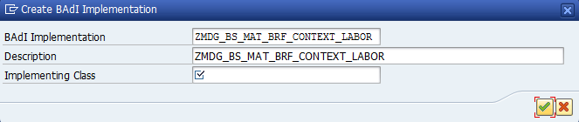

Choose Copy Sample Class 🡪 then choose local Object.

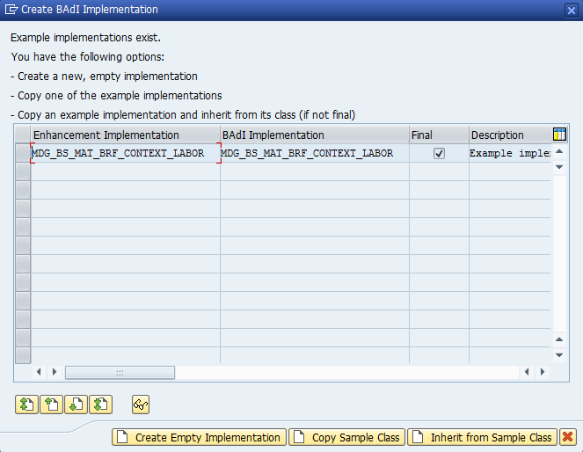

Create filter

i) Click edit in the top left corner then click combination

ii) Double click on the yellow page.

iii) The filter is the service name – value 1 input the service you have created. As such:

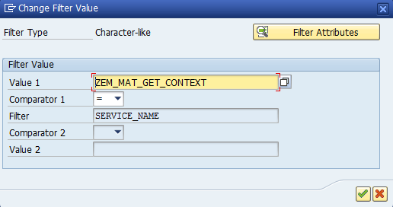

iv) Make sure you save and activate

Locate workflow

i) In SAP easy Access search mdgimg

ii) Open General settings 🡪 Process Modelling 🡪 workflow 🡪 Rule-Based Workflow 🡪 Configure Rule-Based Workflow

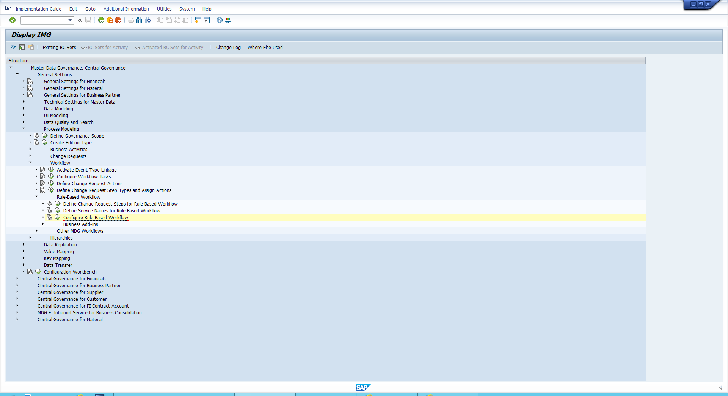

iii) input your change request eg “ZMAT01CK”

Create LABOR

i) on the catalogue structure at the size open the trigger function.

ii) click edit 🡪 Add new data Object 🡪 element

iii) Change binding time to “Bind to DDIC” 🡪 When prompted for element write LABOR

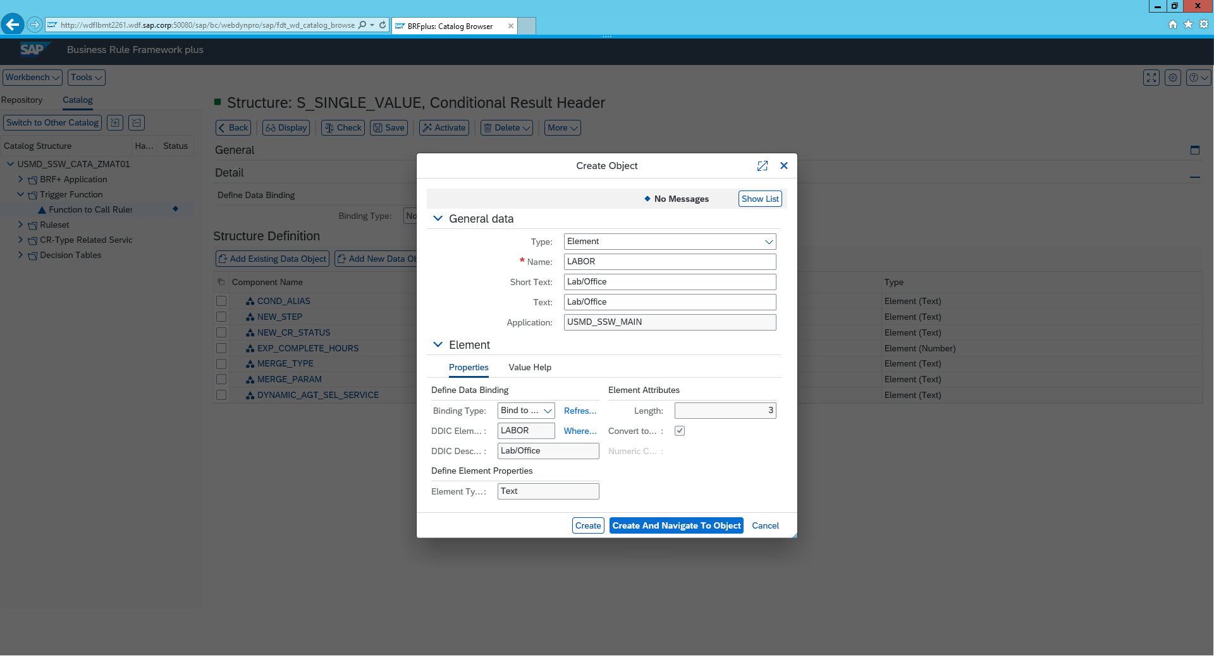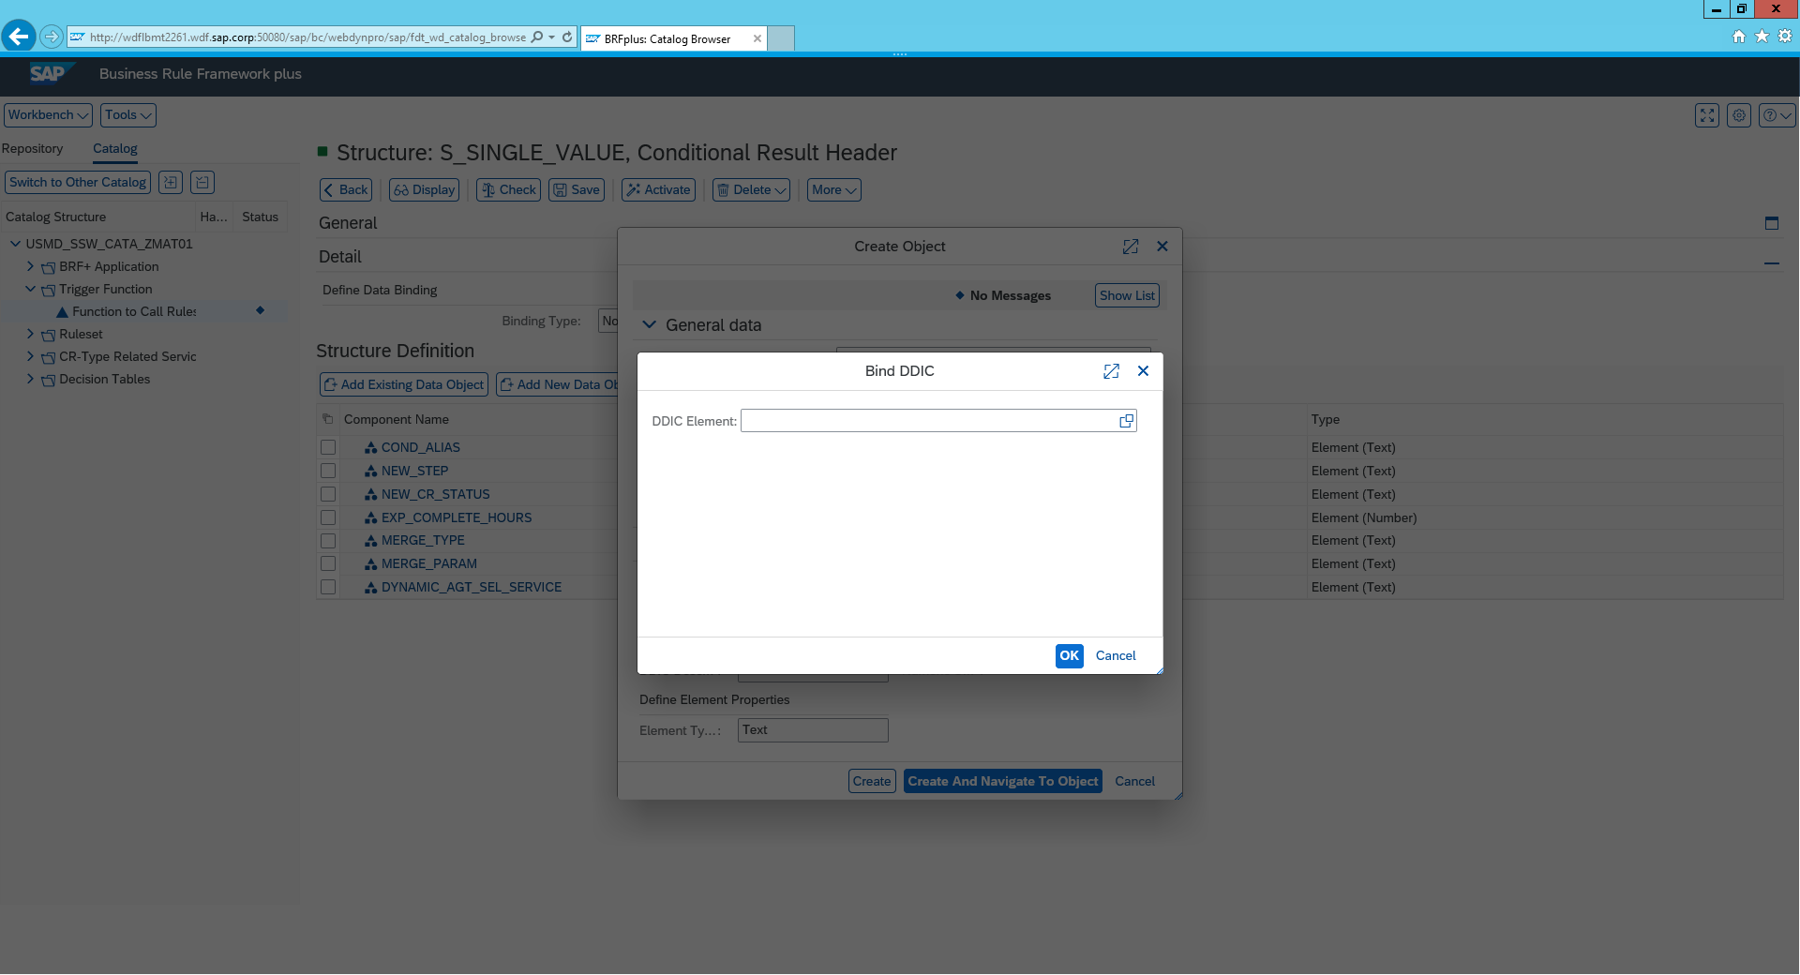

Adding LABOR to the Decision Table

i) Open single value decision table

ii) click edit 🡪 enter table settings and click insert Column from context data Objects

iii) Find LABOR in the list and add

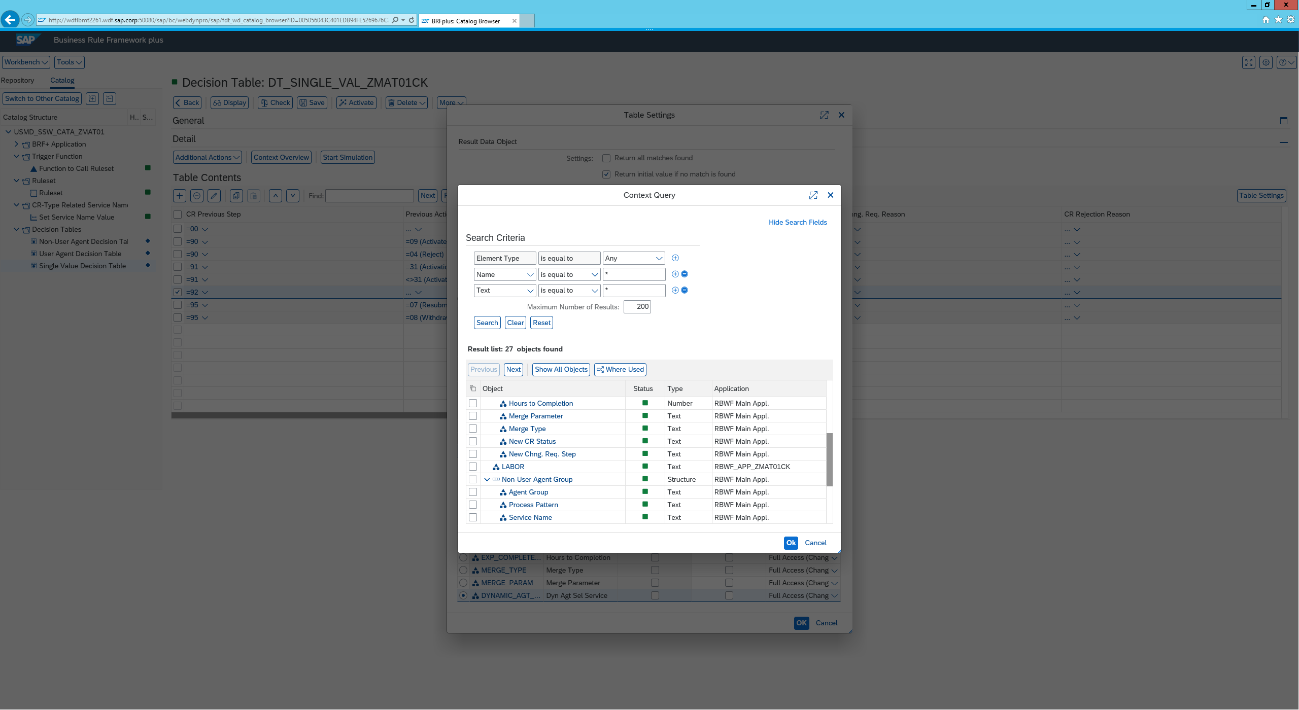

Set Service name

i) Click on CR Type Related Service name

ii) Implement the value of the service you created eg: below

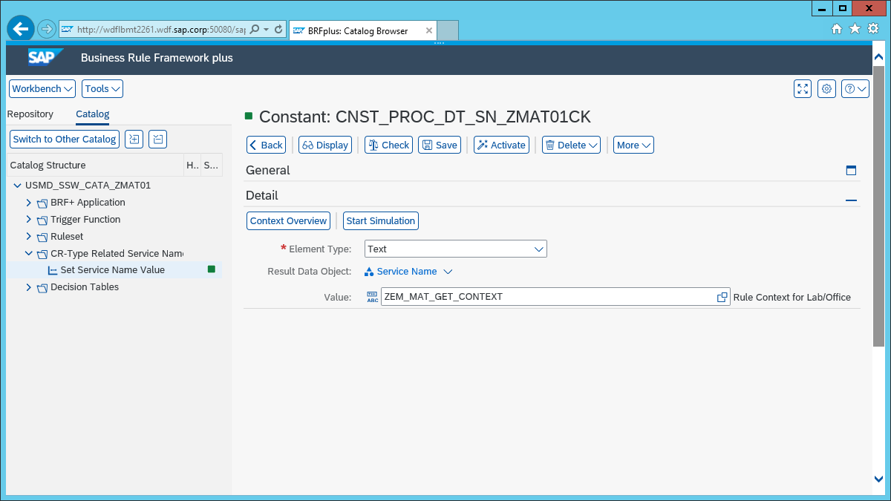

Open the BADI

i) Go back to the mdgimg screen

ii) Open General settings 🡪 Process Modelling 🡪 workflow 🡪 Rule-Based Workflow 🡪 Business Add-Ins 🡪 BAdI Rule Context Preparation for Rule-Based Workflow

iii) select the service and click display information

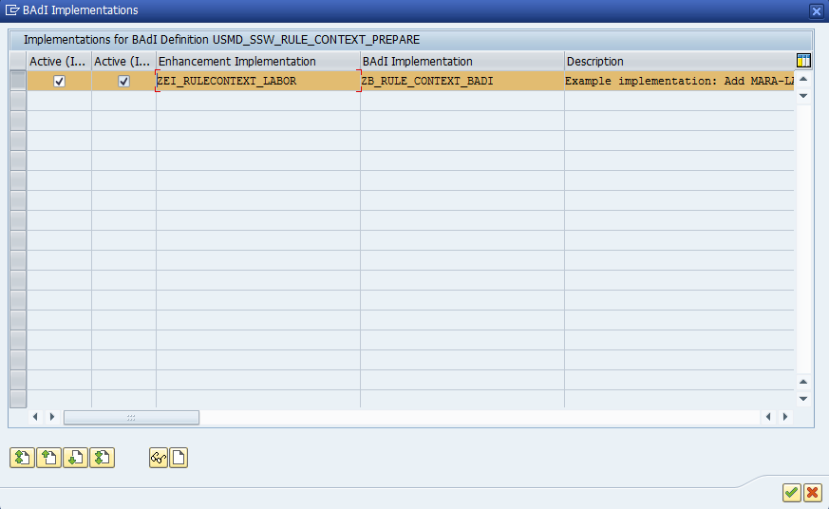

iv) Click implementing class and double click the implementing class - Now you can view the class code.   
V) click into filter values to ensure service filter is implemented

